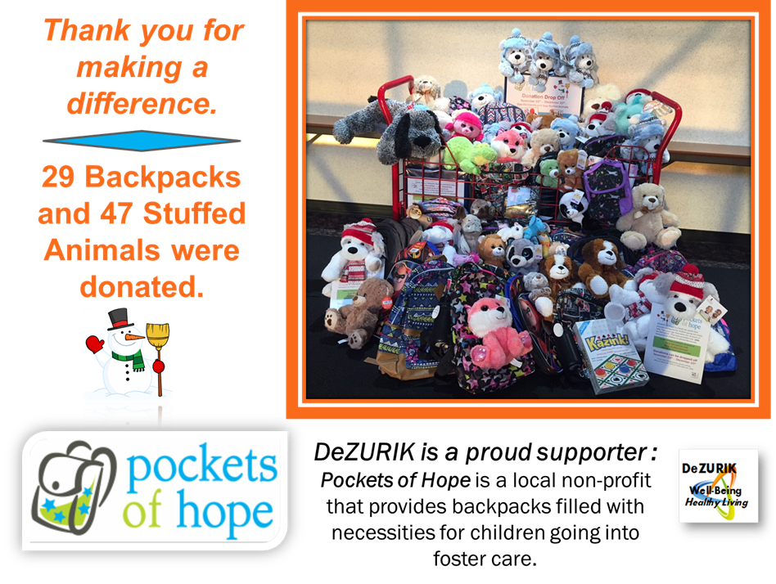

**Thank you to Kay Jewelers**

**for providing 12 stuffed animals!**

|  |  |
| --- | --- |
| [C:\Users\scott\AppData\Local\Microsoft\Windows\INetCache\Content.MSO\4A83D8B5.tmp](http://www.dezurik.com/)  [C:\Users\scott\AppData\Local\Microsoft\Windows\INetCache\Content.MSO\3D9C818B.tmp](http://www.dezurik.com/) |  |